Polypharmacy among the Elderly: Tips to Elude Adverse Effects and drug Interactions
- Among the elderly adults, polypharmacy is a problem that affects 44.0% of men and 57.0% who are aged 65 years and above and take more than five medications weekly.


- Polypharmacy denotes the effects of taking various medications simultaneously to manage the co-existing health complications
- These agents comprise prescription and over-the-counter preparations, like vitamin and mineral supplements
- The ordinarily used medications are aspirin, acetaminophen, and ibuprofen which are readily available OTC. The medication categories commonly involved in the adverse reactions:
- hypoglycemics, steroids,
- cardiovascular agents, diuretics
- antibiotics, opioids,
- anticoagulants, anticholinergics,
- benzodiazepines, anti-inflammatory drugs
- 

The Dangers of Polypharmacy
- Adversative drug reactions
- Drug interactions.
- Increased Health Costs
- Medication Non-adherence
- Functional Status
- Cognitive Impairment
- Urinary Incontinence
- Risk of malnourishment
- Falls and injuries



Tips for Preventive care for the Elderly patient
- Information

Discuss with the patient the need to:
- Maintain an accurate listing of all medications: generic &brand names, dosage, frequency, and reason for taking the drugs
- List of all medical providers and contacts
- Labelling all drugs
- Post name and contacts of local pharmacy

- Instruction

Teach all patients about:
- All medication: name, effects, appearance, and purposes
- Possible adverse effects & interactions
- Significance of contacting the care providers with any concerns
- Drug that need rapid emergency care
- Role of taking drugs as directed


- Organization:
- Aid patients manage drugs and cautioning them on:
- Evading sharing medications
- Proper storage and refrigeration if necessary
- Disposal of old drugs properly
- Diverse effects and drug interactions of all medications
- The role of contacting a care provider with questions
- Drug-related complications that need emergency care
- Role of taking drugs as directed
- The role of using one pharmacy to get drugs

- 
- Establish memory aids

- Link drug administration to routine
- Automatic dispensers - bells
- Voice-activated message services

- Recommend the non-pharmacologic alternatives like dietary changes
- Keeping it Simple

Family Information

Caregivers need knowledge of loved one’s medicines intended usage, directions, side effects, possible drug interaction.

They need contact of health provider and local pharmacy



Practice Recommendations
- Avoid unsuitable medications for older adults due to adverse effects, no efficacy, or potential for drug interactions.
- Discontinuation of medications when harms offset the benefits based on the care goals, life expectancy, or personal preferences.
- Use tools and resources like STOPP/START method and Beers criteria, McLeod criteria to decide when to start the deprescribing procedure.

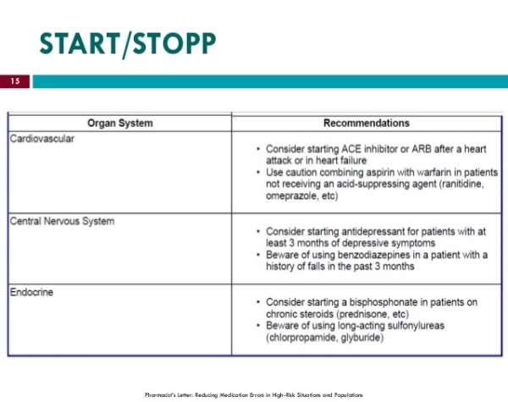

Strengths of recommendation
- High-quality patient evidence
- Limited-quality patient- evidence
- Consensus, usual practices, opinions, disease-evidence, and case series

Community Care Resources
- Senior centres
- Community clinics
- Emergency response
- Medical EHR
- Free periodic consultations
- Proper Lifestyle education

References

Alpert, P. T., & Gatlin, T. (2015). Polypharmacy in older adults. Home Healthcare Now, 33(10), 524-529.

Eng, M. L., & Birch, J. T. (2014). Medication use and polypharmacy in older adults. Geriatric Urology, 55-71.

Gnjidic, D. (2017). Multi-morbidity, geriatric syndromes, and polypharmacy in older adults: Untangling the Evidence. Innovation in Aging, 1

Meraya, A. M., Dwibedi, N., & Sambamoorthi, U. (2016). Polypharmacy and health-related quality of life among U.S adults with arthritis. Medical Expenditure Panel Survey, 2010–2012. Preventing Chronic Disease, 13

Petrovic, M. (2017). Clinical challenges of caring for older adults with multi-morbidity and polypharmacy. Innovation in Aging, 1(Suppl_1), 739-740.

